Th is a sound that can be turned on (voiced) or off (voiceless). Have the child gently open mouth and tick out the tongue just a bit. Then “bite” the tongue with the teeth and “blow” . Then turn on the voice and try again. (think vs. that)
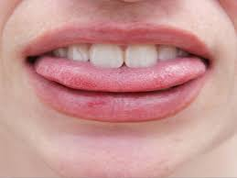

TH
The blowing sounds

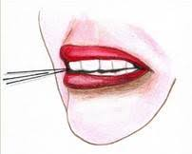
Tongue back and tip UP!

Close your teeth and smile.

/s/ out the middle

Hissing sound

Tongue back and tip UP!

Close your teeth and smile.

/z/ out the middle with voice

Buzzing sound

SH

This sound is called the "be quiet" sound. The sides of the tongue touch the upper teeth. The tongue is flat and is up towards the top of the mouth, push the lips forward, and lightly blow air over the top of the tongue. There is no voice when making this sound, just air.

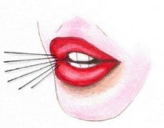
Shshshshshshsh
Shushing “quiet” sound

CH

This sound is just like SH but we use our voice and make it explode. The sides of the tongue touch the upper teeth. The tongue is flat and is up towards the top of the mouth, push the lips forward, and burst air over the top of the tongue.

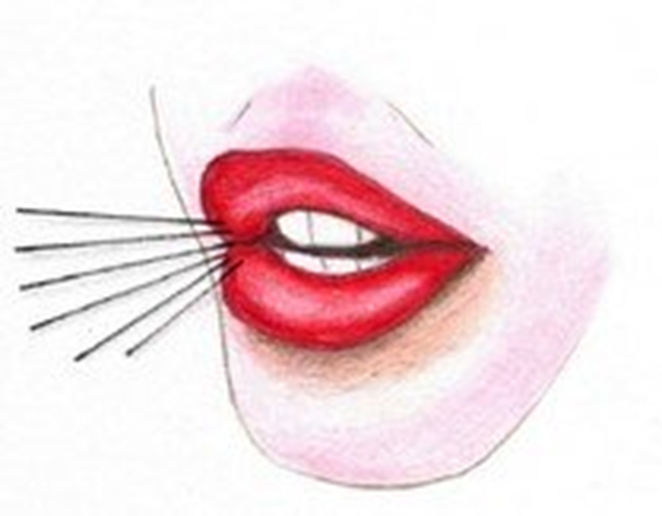
Ch-ch-ch
Choo choo sound

The/r/ is a complicated sound. The sides of the tongue raise to touch the upper teeth (molars). The tongue is flat and is up towards the top of the mouth, the lips push slightly forward, and air is continuous over the top of the tongue.

Errrrrrrrrrrrr
Roaring sound

Different variations of /r/: ar, ir, air, ire, our, our, ear, ore, ure, oor

The /l/ sound needs the tongue to be up and pressing gently right behind the top two teeth,

Tongue back
Tip up
Press
Say /l/
The lalalala singing sound

